uCPE deployment solution

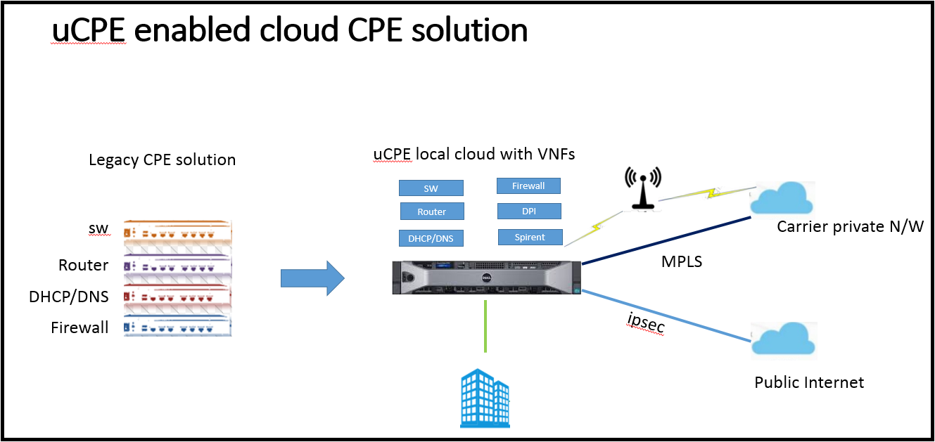

**Let us understand what is Cloud enabled uCPE solution.**

In a telecom network CPE (Customer premise equipment) is a well-known term, where operator install network appliances in customer premise, it has got multiple network functions like CE router, switch firewall, carrier grade L2 and L1 equipment’s. With recent innovations in virtualization technologies telecom vendor products are making S/W applications which run on a general purpose compute H/Ws. Now operator can get network components as S/W applications called VNFs and launch on universal COTS (Commercial off-the-shelf) platform and leverage the virtualization technics to host multiple VNFs under single H/W. So CPE is becoming universal, means a single generic server can host network applications as a VNF, does it sounds great?

Tier-1 and 2 service providers want to simplify CPE deployments. uCPE provide maximum flexibility and agility in application hosting in CPE deployments.

All this is possible by using network function virtualization technology using hypervisor and S/W based VNFs.

Hosting applications in cloud can be done in 4 different ways depending on the use cases.

**1. Centralised cloud compute and controller:**

-Here both Compute resource and control functionality lies in centralized data center location, most of the cloud service provider example AWS does this job (IaaS, PaaS, SaaS)

**2. Compute resource in CPE location and control functionality in centralized location.**

-Service provider can install high end hypervisor CPE servers with compute capability, but control functionality in centralized location.

-Even though CPE is hosting multiple network applications but VNF life cycle management lies with centralized cloud, the disadvantage with this solution is all control packet exchange happens with remote data center, which is not efficient when switching decision has to be made, also control message exchange are exposed in WAN network.

**3. Localized compute and cloud, embedded cloud in uCPE**

Both compute and control functionality in the same CPE, in this solution CPE itself can host VNFs like switch, router, firewall DHCP/DNS application and provide VNF life cycle management locally.

I would say hosting VNFs locally will benefit in many aspects like security, latency, low bandwidth consumption and quick decision in traffic switching scenarios

**4.Hybrid cloud:**

Applications are shared between local cloud and centralized cloud, example: delay sensitive applications can be hosted locally, HA and backup related applications can be hosted in central cloud.

**Options available to virtualize CPE:**

Local **NFVI** (Network Function Virtualization Infrastructure) could be done by using standard open Linux **KVM** (hypervisor)/**QEMU** (VM emulator) libraries and **openstack cloud** infrastructure software. (I will not be discussing much about openstack in this BLOG)

**Benefits a customer can get with uCPE solution:**

* Service provider vendor lock is ruled out, operator simply has to buy the desired VNFs.
* Hardware purchase is under operator control.
* VNF configuration and service chaining is fully open API driven (Netconf/REST/SNMP) hence operator has full control over network configuration.
* Dynamic on-boarding of VNFs, which provide selection of latest VNFs available in the market.

**Current Challenges with uCPE deployment:**

* Service provider operations team has a big task ahead during network issues, who is responsible to debug the issue under this complex network running under one BOX.
* There is no standard service demarcation points defined by any governing body yet.
* Who will do multivendor VNF integration test and provide the data points.
* uCPE can be deployed as brown field which involves both new and legacy network?
* Challenges with OSS/BSS integration under ETOM model.

**Opportunities:**

**Virtualization technology is providing lot of new opportunities in IT networking segment:**

* ADN (Automation Driven Networking), we are automating most of the network appliance deployment by zero touch provisioning.
* Service activation time reduced from Months to mints, faster network deployment and service offering.
* Docker-container based S/W packaging and running applications, which will reduce the Typical VM (dedicated CPU, RAM/ROM) based virtualization.
* Efficient usage of H/W resource which was not possible with hardware driven network appliances.